Name: Niels Clayton Student ID: 300437590

ENGR101 Assignment 5

**Core 1:**

# include < stdio .h >

# include < time .h >

# include " E101 .h "

int main (){

init ();

for(int i = 0; i<5; i++){

write_digital(7,1);

sleep1(1,100000);

write_digital(7,0);

sleep1(0,100000);

}

}

**Core 2:**

# include < stdio .h >

# include < time .h >

# include " E101 .h "

int main (){

init ();

if(read_analog(1) > 300)

{

write_digital(7,1);

}

if(read_analog(1) < 300)

{

write_digital(7,0);

}

}

**Completion 1:**

# include < stdio .h >

# include < time .h >

# include " E101 .h "

void switching(int dt){

int time = 0;

while (time < dt){

write_digital(7,1);

sleep1(0,200);

write_digital(7,0);

sleep1(0,200);

time = time + 400;

}

}

int main (){

init();

switching(10000000); // 10 seconds of 50% duty cycle

}

**Challenge 1:**

# include < stdio .h >

# include < time .h >

# include " E101 .h "

void switching(){

int speed = 100000;

while (true){

printf(“current speed is”%f\n,speed);

write_digital(7,1);

sleep1(0,speed);

write_digital(7,0);

sleep1(0,speed);

speed = speed - 200;

if(speed <=100){

speed = 100;

}

}

}

int main (){

init();

switching();

}

Core 3:

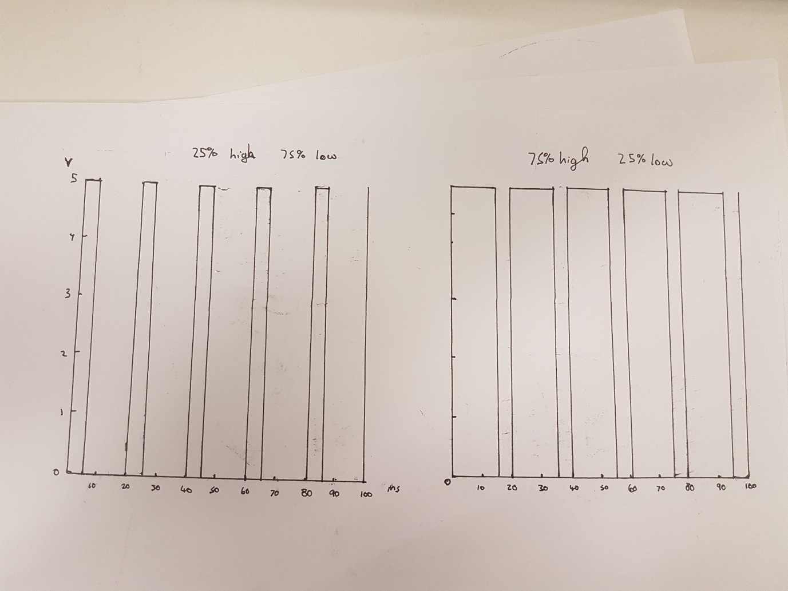

Core 4:

int main (){

init();

set_motor(1,127);

set_motor(2,127);

sleep1(1,0);

stop(1);

stop(2);

return 0;

}

Completion 2:

void turn_left(int angle){

//assuming that motor 1 is on the left side

set_motor(1,-127);

set_motor(2,127);

sleep1(0,angle);

}

Core 5:

set_motor (1 ,102); PWM is 40% (motor is on 40% of the time)

set_motor (1, 153); PWM is 60% (motor is on 60% of the time)

Challenge 2:

int main (){

init();

sensor_motor(read_analog(0));

}

}

void sensor_motor(int speed){

if (speed > 200){

set_motor(1, -100 -(speed/10));

set_motor(2, -100 -(speed/10));

}

else{

set_motor(1, 100 + speed/5;

set_motor(2, 100 +speed/5));

}

}